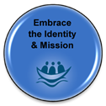 | Embrace the Identity & Mission  We are inspired to live the L’Arche Mission every day
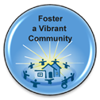 | Foster A Vibrant Community  We share an extraordinary life in community
Celebrate the Value of Each Person

We appreciate each person for their unique way of being
Open to Mutual Relationships

We develop meaningful, life‐changing friendships
Journey Together with Respect

We care about how our actions affect others
Nurture our Gifts and Growth

We support one another’s growth and gifts
Fulfill your Role in Community

We care about our roles and live them well
Trust in God

We see and discover a spiritual meaning in day‐to‐day life
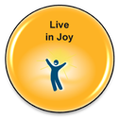 | Live in Joy  We create fun and share our joy
Stand on Humble Ground

We earn trust and acceptance when we come as we are
Shape a More Human Society

We share the vision and spirit of L’Arche beyond our community and change the world

